## **Adobe Acrobat DC**

## **Pre-requisites:**

* To download the ‘Adobe Acrobat DC’ file follow the below steps:
* 1. Download the Adobe Acrobat DC file from the below URL.
* 2.File: AcroRdrDC2101120039_en_US.exe
* 3.URL: https://ardownload2.adobe.com/pub/adobe/reader/win/AcrobatDC/2101120039/AcroRdrDC2101120039_en_US.exe
* Note: - Click on the given URL then downloading will start automatically.
* 4.User should have Administrator right to install software
* Steps: Follow the below steps to copy Adobe Acrobat DC:
* 1. Log in to the machine where Adobe Acrobat DC will be copy.
* 2. Go to the location where 'AcroRdrDC2101120039_en_US.exe' setup file is downloaded.
* 3. Copy the 'AcroRdrDC2101120039_en_US.exe' setup file.
* 4. Navigate to the specific directory where 'AcroRdrDC2101120039_en_US.exe' will be copied. (C:\Share\adobe-acrobat-dc)
* 5. Paste the copied 'AcroRdrDC2101120039_en_US.exe' setup 'file.

## **Installation:**

* Steps: Follow the below steps to install Adobe Acrobat DC:
* 1. Log in to the machine where Adobe Acrobat DC will be installed.
* 2. Navigate to the directory where 'AcroRdrDC2101120039_en_US.exe' file is copied.
* 3. Double click on 'AcroRdrDC2101120039_en_US.exe'. After that 'Welcome to the Adobe Acrobat DC Setup Wizard' will be opened.
* 4. Click on 'Install' button.
* 5. After a few moments 'Completed the Adobe Acrobat DC Setup Wizard' windows will be opened'. Click on 'Finish' button.
* Now Adobe Acrobat Reader DC has been successfully installed.

1. Double click on 'AcroRdrDC2101120039_en_US.exe'. After that 'Welcome to the Adobe Acrobat DC Setup Wizard' will be opened.

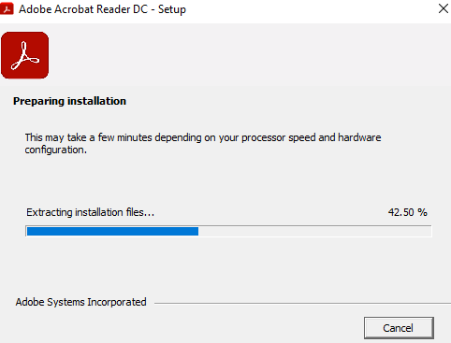

2. Click on 'Install' button. Find snapshot for reference.

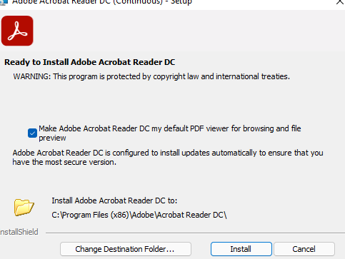

3. Installation process in process, find below snapshot for reference.

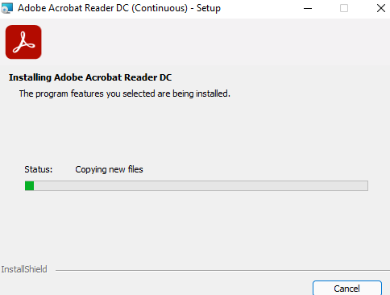

4. After a few moments 'Completed the Adobe Acrobat DC Setup Wizard' windows will be opened'. Click on 'Finish' button.

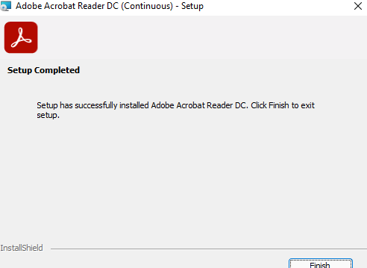

## **Verification:**

* Open 'Control Panel'.
* Navigate to 'Programs\Programs and Features'.
* ‘Adobe Acrobat Reader DC’ must be present in the installed software list.

